ANANYA 2023-24
Theme of the Year- Aspire, Acquire, Inspire

For the annual intra-collegiate festival Ananya (2023-24) departments from the arts and the sciences organised events and activities around the theme of the year “Aspire, Acquire, Inspire”.
The Department of Psychology organized a Speed Reading Workshop on 2nd February 2024 from 8:00 am to 11:00 am, held in the AV (F) Hall. Ninety-two students actively participated in this workshop supported by RUSA, aimed at enhancing their reading speed and comprehension skills. The session was led by Dr. Hozefa Bhidewala, a renowned psychiatrist, along with his team. Participants were introduced to scientifically validated speed-reading techniques such as reduction of subvocalizing and the use of a launcher. The workshop was highly interactive, consisting of multiple reading passages used to measure progress, with students ultimately demonstrating a 50–75% increase in reading speed. The combination of teaching, practice, and feedback made the event practical, engaging, and beneficial for the attendees.

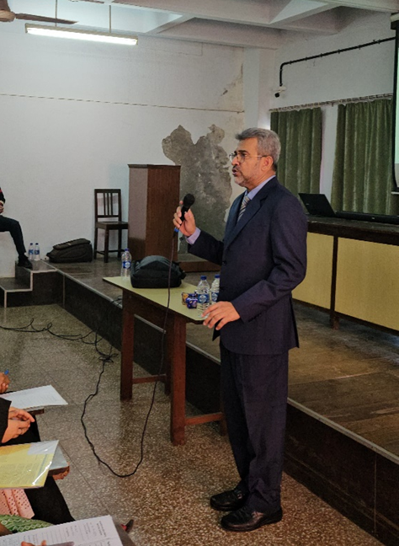

The Chemistry Department hosted an informative session titled “Chemical Sciences and Career Opportunities” on 12th January 2024 at the AV Hall. Targeted at undergraduate and postgraduate students, the event aimed to enlighten them about the vast research and career opportunities in chemical sciences, emphasizing the importance of interdisciplinary approaches in contemporary scientific fields. Prof. Dimple Dutta from the Homi Bhabha National Institute, BARC Mumbai, was the resource person. The session was divided into two parts: the first discussed research opportunities both in India and abroad, while the second highlighted job prospects in government and nongovernment sectors. A Q&A segment allowed students to clarify doubts and engage directly with the expert. The talk was well received by all present, providing valuable insight into their potential career paths.
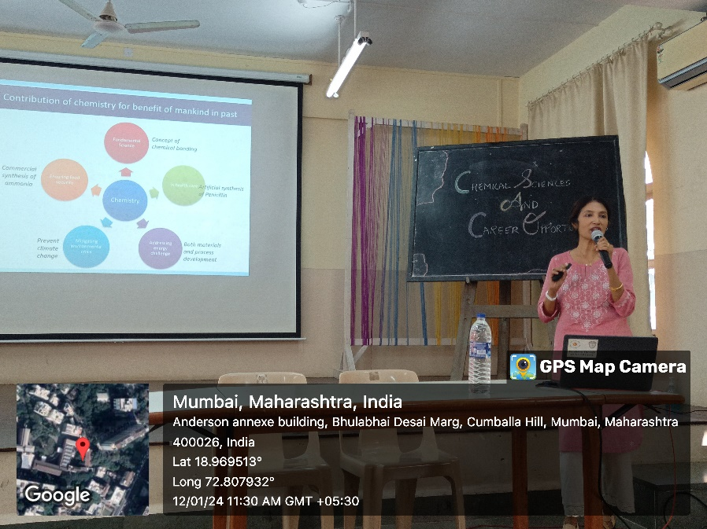
On 3rd February 2024, the Department of Zoology conducted an International Webinar focused on the benefits of practicing mindfulness, held as an in-house online session attended by 48 students and two staff members. The session was designed for undergraduate students from BA and B.Sc. programs, in alignment with the college’s theme "Aspire, Acquire, Inspire." Ms. Shanti Pise, a motivational speaker and wellness coach from London, conducted the session, emphasizing the importance of a positive attitude, building resilience, goal setting, and time management during the formative student years. The webinar also incorporated live meditation exercises that encouraged active engagement, with students interacting through questions and sharing their own stress management strategies. Feedback from participants reflected significant appreciation of the session’s value in promoting mental well-being.
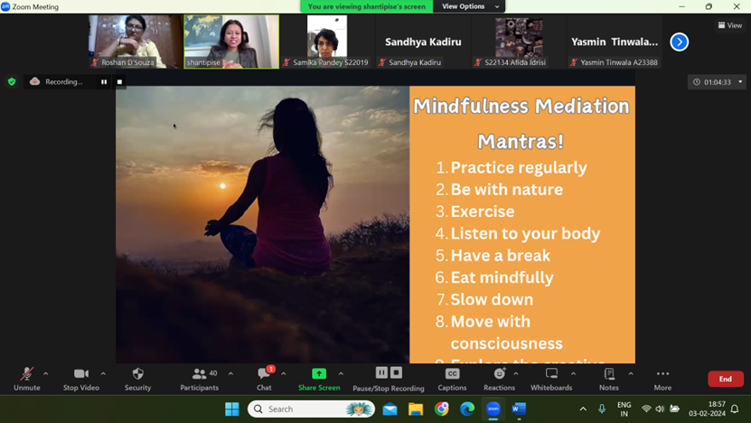
The Departments of Philosophy and Psychology collaboratively organized the “Leadership and You” workshop on 20th January 2024 from 10 am to 12 noon at the AV Hall. The workshop was attended by 78 participants and aimed to empower emerging student leaders by imparting leadership virtues and frameworks grounded in Design Thinking. Speakers Mr. Shubh Mehta and Ms. Vidi Panwar from Change Is Us (CIU) guided the participants through various leadership perspectives including creative thinking and profit-focused models. The session culminated in a 30-minute activity where students actively applied their newly learned leadership skills to hypothetical situations. The workshop was successful in encouraging leadership aspirations among students and providing practical insights from youth leaders themselves.
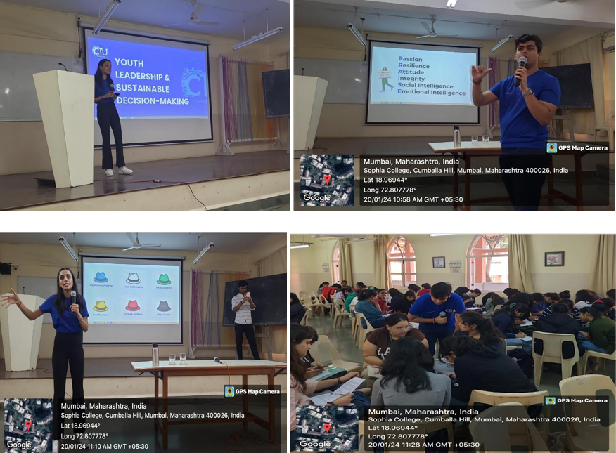
On 26th February 2024, the Department of Economics hosted an event titled “Budget 101: Unveiling the Union Financial Roadmap 2024” at the AV Hall, led by second-year BA students under faculty supervision. The event was conceived to familiarize students with the interim Union Budget announced on 1st February 2024. It began with an introductory video followed by detailed presentations that covered recent reforms in sectors such as taxation, green energy, physical infrastructure, education, and women-centric initiatives like Amrit Peedhi. The session concluded with a quiz that encouraged participation and tested students’ understanding of the budget contents and related general knowledge. The event was well-organized and fostered enthusiasm and collaborative learning among student volunteers and attendees.
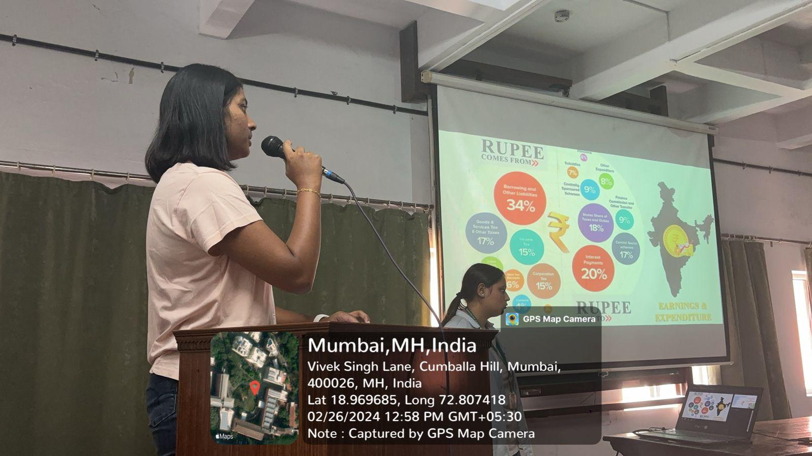
The Microbiology Department conducted “Micro Mania,” an intercollegiate event on 10th January 2024 from 9:30 am to 12:30 pm, at the UG Microbiology Laboratory and the Canteen Extension area. The event attracted 27 participants from different colleges, engaging them in microbiology-related activities. The first event, “Microbial Imposters,” was a team-based game comprising seven teams of three members each, held in the laboratory, which tested participants’ microbiology knowledge competitively. Following this, the “Cell-Fie” creative competition involved participants submitting cellular drawings via email. The event was successfully judged by Dr. Vaishali Pachunde, and winners were announced at the event’s conclusion. The activity fostered intercollegiate engagement and enthusiasm in the field of microbiology.
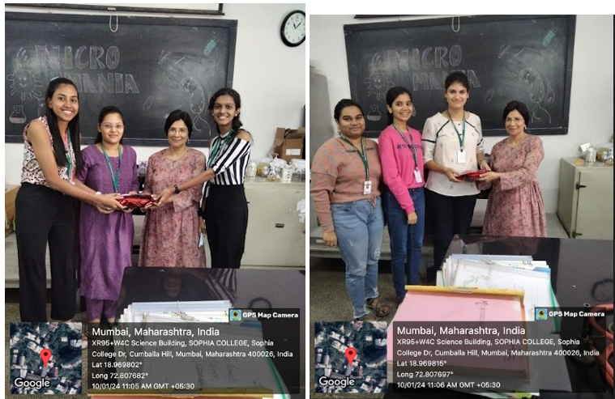
The Department of Education organized an orientation session for newly admitted B.Ed. students on 19th January 2024 starting from 1:15 pm. The event began with a brief preparatory meeting between resource persons and college leadership followed by warm welcome notes from Ms. Naqiya and Ms. Insiya. A session was then conducted by Prof. Adonis Braganza, which included an interactive Q&A segment allowing participants to clarify expectations. The orientation concluded at 3:00 pm with a vote of thanks by Ms. Sakina, effectively initiating the academic journey of the B.Ed. students.
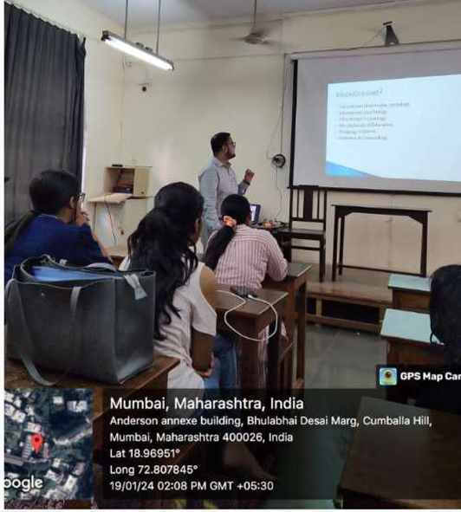
The departments of History, Mathematics, and Statistics organized a talk titled “Careers in Education – Options and Opportunities” on January 28, 2023, as part of Ananya 2023. The event featured Ms. Lamiya Tambawala, Senior Vice President, Academics at JBCN Education, as the guest speaker and was attended by over 80 students from the three departments. Ms. Tambawala began by reflecting on her own student days and the significant influence her college professors had on her graduation. She then provided insights into the evolving education sector, emphasizing the growing roles of Information Technology, Artificial Intelligence, and Machine Learning. Highlighting emerging career options, Ms. Tambawala noted the expanding opportunities in education and the diverse skills required in today’s job market. She also shared personal experiences and her career journey, making the session relatable and informative.
The Department of English organized a RUSA-supported production of Harold Pinter’s play The Caretaker by the Aabhas theatre group on December 13, 2023, in the AV Hall. Nishtha Dev coordinated the event with co-coordinators Dr. Elwin Susan John, Ms. Samrita Sengupta Sinha, and Ms. Jihasa Vachharajani, and over 100 students participated as both audience members and volunteers, linking the event closely to the TYBA syllabus focusing on playwrights including Beckett. The rationale for the event centered on immersing students in existentialist themes such as existential angst, alienation, identity crisis, absurdity, futility, and psychological depth by analysing characters and narratives in The Caretaker and Beckett’s Waiting for Godot, thereby enhancing critical thinking and empathy. Students engaged in comparative analysis to appreciate the different narrative styles and existential themes presented in the two plays, deepening their literary analysis skills. Additionally, organizing the production provided practical experience in collaborative planning, coordination, problem-solving, and adaptability, as students had to manage rehearsals, roles, resources, and overcome logistical challenges, fostering teamwork and real-world skills. Overall, the event combined literary exploration with hands-on learning, enriching the students' understanding of existentialist literature and building valuable collaborative and adaptive skills.
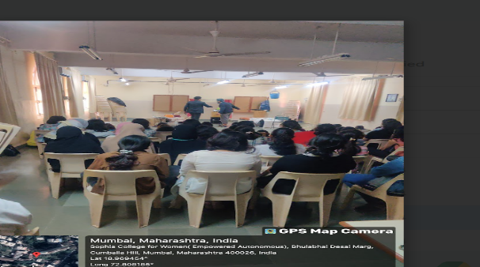
The Hindi department of Sophia College hosted a movie screening of "12th Fail" on February 9th, 2024, as part of their Ananya Activity. The event was well-attended by students from various streams who enjoyed the film. The screening aimed not only to entertain but also to motivate and inspire students by highlighting themes of life, hard work, and achieving success through determination. The positive reactions and smiles of the students marked the event as a successful and uplifting experience.
